PUBLIC NOTICE
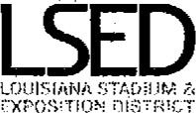
Pursuant to Louisiana law, Public Notice is hereby given that the Louisiana Stadium and Exposition District ("LSED") Board meeting scheduled for Thursday, May 23, 2019, at 1:00 P.M. is CANCELLED. The June Board meeting is scheduled for Friday, June 14, 2019, at I P.M.

Louisiana Stadium and Exposition District
Kyle M. France, Chairman
Henry N. Baptiste Kathleen B. Blanco Hilary H. Landry
Renee A. Lapeyrolerie Gregory A. Morrison Casey J. Robin
1500 Girod Street New Orleans, LA 70112 504.587.3913 504.587.3517 (fax)

